#### SAVITRIBAI PHULE PUNE UNIVERSITY A PROJECT REPORT ON

**Crop Recommendation and Plant Leaf Disease Predication using CNN**

SUBMITTED TOWARDS THE

PARTIAL FULFILLMENT OF THE REQUIREMENTS OF

### BACHELOR OF ENGINEERING

in

### COMPUTER ENGINEERING BY

**Sakshi Dherange 72281016E**

**Shital Mehetre 72281021M**

**Vrushali Datir 72281015G**

**Vrushali Patil 72281023H**

### Under The Guidance of

Mrs. Deepali Gohil Mrs. F.S.Sayyad



**DEPARTMENT OF COMPUTER ENGINEERING**

**D. Y. Patil College of Engineering, Akurdi.**



**D. Y. Patil College of Engineering, Akurdi. DEPARTMENT OF COMPUTER ENGINEERING**

**CERTIFICATE**

This is to certify that the Project Entitled

### Crop Recommendation and Plant Leaf Disease Prediction using CNN

Submitted by

Sakshi Dherange 72281016E

Shital Mehetre 72281021M

Vrushali Datir 72281015G

Vrushali Patil 72281023H

is a bonafide work carried out by Students under the supervision of Mrs. Deepali M. Gohil and it is submitted towards the partial fulfillment of the requirement of Bachelor of Engineering (Computer Engineering).

Prof. D. M. Gohil Dr. M. A. Potey

Asst. Professor H.O.D

Dept. of Computer Engg. Dept. of Computer Engg.

Dr. P. Malathi Principal

D. Y. Patil College of Engineering, Akurdi Pune 44

Signature of Internal Examiner Signature of External Examiner

#### PROJECT APPROVAL SHEET

A Project

Crop Recommendation and Plant Leaf Disease Prediction using CNN

Is successfully completed by Sakshi Dherange 72281016E

Shital Mehetre 72281021M

Vrushali Datir 72281015G

Vrushali Patil 72281023H

at

DEPARTMENT OF COMPUTER ENGINEERING

(D. Y. Patil College of Engineering, Akurdi.) SAVITRIBAI PHULE PUNE UNIVERSITY,PUNE ACADEMIC YEAR 2023-2024

Mrs. Deepali Gohil Dr. M. A. Potey

(Internal Guide) (Co-Guide)

Dept. of Computer Engg. Dept. of Computer Engg.

### Abstract

The production of high-quality food depends on the agricultural sector, which also makes the largest contribution to growing economies and people. A revolutionary method of farming that aims to maximize crop productivity while reducing resource use and environmental effect is precision agriculture. In order to help farmers make educated decisions, this system approach combines Convolutional Neural Networks (CNN) for plant leaf disease prediction with crop recommendation systems. Given the growing need for environmentally friendly agricultural methods and the growing risk of crop diseases. Early detection of plant diseases can lower financial losses and increase the quality of food production through the use of automated or precise diagnostic techniques. These days, crop disease identification is a hot analytical topic. Therefore, it is essential to identify and categorize crop diseases in order to increase crop productivity and the economic process.

***Keywords:*** *CNN, Decision Tree, Neural Network, Image Processing, Regression.,*

### Acknowledgments

With immense pleasure, we present the project report as part of the curriculum of the B.E. Computer Engineering.

*It gives us great pleasure in presenting the preliminary project report on* ***‘Crop Recommendation and plant leaf disease prediction using CNN’****.*

*I would like to take this opportunity to thank my internal guide* ***Mrs. D. M. Gohil*** *for giving me all the help and guidance I needed. I am really grateful to them for their kind support. Their valuable suggestions were very helpful.*

*I am also grateful to* ***Dr. M. A. Potey****, Head of Computer Engineering Department, DYP- COE for his indispensable support, suggestions.*

*In the end our special thanks to* ***Mrs. F. S. Sayyad*** *for providing various resources such as laboratory with all needed software platforms, continuous Internet connection, for Our Project.*

Sakshi Dherange Shital Mehetre Vrushali Datir Vrushali Patil

(B.E. Computer Engg.)

# Contents

1. Synopsis 1-5
   1. Project Title 1
   2. Project Option 1
   3. Internal Guide 1
   4. Sponsorship and External Guide 1
   5. Technical Keywords (As per ACM Keywords) 1
   6. Problem Statement 2
   7. Abstract 2
   8. Goals and Objectives 2
   9. Relevant mathematics associated with the Project 3
   10. Names of Conferences / Journals where papers can be published 3
   11. Review of Conference/Journal Papers supporting Project idea 4
   12. Plan of Project Execution 5
2. Technical Keywords 6
   1. Area of Project 6
   2. Technical Keywords 6
3. Introduction 7-9
   1. Project Idea 7
   2. Motivation of the Project 7
   3. Literature Survey 8
4. Problem Definition and scope 10-13
   1. Problem Statement 10
      1. Goals and objectives 10
      2. Statement of scope 11
   2. Major Constraints 11
   3. Methodologies of Problem solving and efficiency issues 11
   4. Outcome 12
   5. Applications 12
   6. Hardware Resources Required 13

III

* 1. Software Resources Required 13

1. Project Plan 19
   1. Project Estimates 14
      1. Reconciled Estimates 14
      2. Project Resources 15
   2. Risk Management w.r.t. NP Hard analysis 15
      1. Risk Identification 15
      2. Risk Analysis 16
      3. Overview of Risk Mitigation, Monitoring, Management 16
   3. Project Schedule 17
      1. Project task set 17
      2. Task network 17
      3. Timeline Chart 18
   4. Team Organization 18
      1. Team structure 18
      2. Management reporting and communication 19
2. Software requirement specification 30
   1. Introduction 20
      1. Purpose and Scope of Document 20
      2. Overview of responsibilities of Developer 21
   2. Usage Scenario 22
      1. User profiles 23
      2. Use-cases 24
      3. Use Case View 25
   3. Functional Model and Description 26
      1. Data Flow Diagram 26
      2. Activity Diagram: 27
      3. Non Functional Requirements: 28
      4. State Diagram: 29
      5. Software Interface Description 30
3. Detailed Design Document using Appendix A and B 31
   1. Introduction 31
   2. Data design (using Appendices A and B) 31
      1. Internal software data structure 31
      2. Database description 31
   3. Architectural Design 32
   4. Component Design 33
      1. Sequence Diagram 33
4. Project Implementation 34
   1. Introduction 34
   2. Tools and Technologies Used 34
   3. System Modules
      1. Admin 34
      2. View and Authorize Users 35

8.3.3 Ecommerce Users 35

1. Software Testing 36
   1. Type of Testing Used 36
   2. Test Cases and Test Results 37
2. Results 38
   1. Screen shots 38
   2. Outputs 40

11 Deployment and Maintenance 41

11.1 Operational Requirements to run the System…………………………………..41

12 Conclusion and future scope 42

Appendix References 43-44

Appendix Paper published Status 45

Appendix Plagiarism Report 46-48

Appendix Information of Project Group Members 49

* 1. Iterative Development Model 14
  2. Fig. Task Network 17
  3. Fig. Time Line GANTT chart 18
  4. Use Case Diagram 25
  5. DFD Level 0 26
  6. DFD Level 1 26
  7. DFD Level 2 26
  8. Sequence Diagram 27
  9. State transition diagram 29
  10. System Architecture 32
  11. Component Diagram 33

1. Plagiarism Report of Abstract 42
2. Plagiarism Report of Introduction 43
3. Plagiarism Report of Problem Statement 44
4. Plagiarism Report of Application 45

|  |  |  |
| --- | --- | --- |
| 1.1 | Project Planner . . . . . . . . . . . . . . . . . . . . | . 5 |
| 5.1 | Team Structure for the Project . . . . . . . . . . . . | . 18 |
| 9.1 | Testcases . . . . . . . . . . . . . . . . . . . . . . . | . 37 |
| 1 | Plagiarism Report . . . . . . . . . . . . . . . . . . . | . 45 |

# Synopsis

## Project Title

Crop Recommendation and Plant Leaf Disease prediction using CNN

## Project Option

BE Final Year Project

## Internal Guide

Prof. Mrs. D. M. Gohil and Mrs. F. S. Sayyad

## Sponsorship and External Guide

Not Sponsored

## Technical Keywords (As per ACM Keywords)

1. Anaconda Navigator
2. Spyder
3. Tkinter Language.
4. Python
5. Encryption
6. CNN Algorithm

## Problem Statement

To enhance agricultural practices, understanding soil types and their suitability for different crops is vital. Leveraging machine learning techniques, we propose a multi-step solution. Plant diseases, often caused by pests and pathogens, can lead to substantial yield losses. The proposed technology enables early detection of leaf diseases and continuous monitoring of cultivated areas, helping farmers mitigate losses and optimize crop selection, even at the onset of disease symptoms. Predicting crop yields is a significant agricultural issue. The main factors affecting agricultural yield are pesticides. Making judgements about agricultural risk management and forecasting the future requires accurate knowledge of crop yield history.

## Abstract

The production of high-quality food depends on the agricultural sector, which also makes the largest contribution to growing economies and people. A revolutionary method of farming that aims to maximize crop productivity while reducing resource use and environmental effect is precision agriculture. In order to help farmers make educated decisions, this system approach combines Convolutional Neural Networks (CNN) for plant leaf disease prediction with crop recommendation systems. Given the growing need for environmentally friendly agricultural methods and the growing risk of crop diseases. Early detection of plant diseases can lower financial losses and increase the quality of food production through the use of automated or precise diagnostic techniques. These days, crop disease identification is a hot analytical topic. Therefore, it is essential to identify and categorize crop diseases in order to increase crop productivity and the economic process.

## Goals and Objectives

The main goals and objective of the system are as follows:

1. The goal is to empower users in the field of agriculture. The aim is to provide a robust learning platform that equips users with knowledge about crop management and plant diseases, enabling them to make well-informed decisions.
2. To offer a reliable crop recommendation system that considers factors like soil conditions and climate, thereby helping users improve their crop yields.
3. Our objective is to implement a trustworthy disease detection system that accurately identifies plant diseases.

## Relevant mathematics associated with the Project

Let S represent the entire system, where S = I, P, O. Where:

* I represents the input, which consists of image data.
* P represents the procedures or operations applied to the input, using I to make predictions.
* O represents the output, which includes the system's predictions related to crop selection and plant leaf disease.

#### Input (I):

* I is composed of image data, which serves as input to the system.

#### Procedures (P):

* P consists of the operations performed using the input (I) to make predictions. These operations include the assessment of the image data to determine both crop predictions and plant leaf disease predictions.

#### Output (O):

* represents the system's predictions, which include crop recommendations and the detection of plant leaf diseases.

## Names of Conferences / Journals where papers can be published

* IEEE/ACM Conference/Journal
* Conferences/workshops in IITs
* Central Universities or SPPU Conferences

## Review of Conference/Journal Papers supporting Project Idea

* **Name:** A Systematic Literature Review on Plant Disease Detection: Motivations, Classification Techniques, Datasets, Challenges, and Future Trends

**Standard:** Inf. Process. Syst.

**Author:** Wasswa Shafik Ali Tufail, Abdallah Namoun, Liyanage Chandratilak De Silva , Rosyzie Anna Awg Haji Mohd Apong

**Year:** 2023

* **Name:** Crop Prediction Based on Characteristics of the Agricultural Environment Using Various Feature Selection Techniques and Classifiers

**Author:** S. P. Raja, Barbara Sawicka, Zoran Stamenkovic, And G. Mariammal

**Year:** 2022

* **Name:** Fast Plant Leaf Recognition Using Improved Multiscale Triangle Representation and KNN for Optimization

**Author:** Jianyu Su, Meihua Wang, Zhenxin Wu, And Qingliang Chen

**Year:** 2020

* **Name:** Machine learning based Pedantic Analysis of Predictive Algorithms in Crop Yield Management

**Author:**  M Chandraprabha, Rajesh Kumar Dhanaraj

**Year:** 2020

## Plan of Project Execution

|  |  |  |  |  |
| --- | --- | --- | --- | --- |
| Sr. No. | Task | Duration | Start Date | End Date |
| 1. | Group Formation | 6 | 21 July | 26 July |
| 2. | Decide Area of Interest | 2 | 26 July | 28 July |
| 3. | Search Topic | 5 | 28 July | 6 Aug |
| 4. | Topic Selection | 5 | 6 Aug | 16 Aug |
| 6. | Search Related Information | 12 | 16 Aug | 22 Aug |
| 7. | Understanding Concept | 7 | 22 Aug | 12 Aug |
| 8. | Search Essential Document Software | 6 | 12 Aug | 20 Sep |
| 9 | Problem Definition | 2 | 20 Sep | 31 Sep |
| 10 | Literature Survey | 5 | 31 Sep | 8 Oct |
| 11. | SRS | 12 | 8 Oct | 18 Oct |
| 12. | Project Planning | 20 | 18 Oct | 20 Nov |
| 13. | Modeling and design | 20 | 30 Nov | 15 Dec |
| 14. | Technical Specification | 15 | 20 Dec | 30 Dec |
| 15. | Report & PPT | 5 | 2 Jan | 5 Jan |

Table 1.1: Project Planner

# Technical Keywords

## Area of Project

A project on "Crop Recommendation and Plant Leaf Disease Prediction" involves developing a technology-driven solution that helps farmers make informed decisions about crop selection and provides early detection of plant diseases. It encompasses various components, including data collection, machine learning models, technology integration, education, and monitoring. The project aims to improve crop yields, reduce disease-related losses, and promote sustainable farming practices while considering regulatory and ethical aspects. Its scope may vary depending on resources and objectives but generally involves a comprehensive approach to modernize agriculture.

## Technical Keywords

1. Anaconda Navigator
2. Spyder
3. Tkinter Language.
4. Python
5. Encryption
6. CNN Algorithm

# Introduction

In today's ever-evolving agricultural landscape, the integration of technology is revolutionizing the way we approach crop cultivation and disease management. "Crop Recommendation and Plant Leaf Disease Prediction" is a cutting-edge project at the intersection of agriculture and technology. It seeks to address the pressing challenges faced by farmers by providing them with data-driven solutions. This project is divided into two crucial components. The first component focuses on crop recommendation, utilizing historical data, soil analysis, and weather information to advise farmers on the best crop choices for their specific region. The second component involves plant leaf disease prediction, employing image recognition and predictive modeling to detect and forecast disease outbreaks in their early stages.

## Project Idea

To develop the "Crop Recommendation and Plant Leaf Disease Prediction using CNN" project, the idea stems from the need to empower farmers with data-driven decision- making. The project is inspired by the potential of modern technology, such as CNNs, to aid in crop selection and disease identification. It draws upon the importance of agricultural knowledge and the benefits of user-friendly interfaces. The aim is to create a tool that combines education and practical solutions, ultimately improving agriculture, reducing crop losses, and enhancing food security.

## Motivation of the Project

The motivation for the "Crop Recommendation and Leaf Disease Prediction using CNN" project is to harness the power of data-driven technologies to address critical challenges in agriculture. By employing Convolutional Neural Networks (CNNs), the project aims to enhance crop management and food security. It empowers farmers with personalized crop recommendations and early disease detection, enabling them to make informed decisions, optimize resource utilization, and protect their crops. In an era of changing environmental conditions, this project underscores the importance of data-driven solutions to boost agricultural productivity and ensure global food security.

## Literature Survey

|  |  |  |  |
| --- | --- | --- | --- |
| **Sr.**  **No.** | **Title and Authors** | **Conference/ Journal Name and Publication Year** | **Topic Reviewed/ Algorithms or methodology used** |
| 1. | A Systematic Literature Review on Plant Disease Detection: Motivations, Classification Techniques, Datasets, Challenges, and Future Trends | Wasswa Shafik Ali Tufail, Abdallah Namoun, Liyanage Chandratilak De Silva , Rosyzie Anna Awg Haji Mohd Apong  (2023) | Nearly all important plant species and the security of the world's food supply are seriously threatened by plant pests and diseases.As a result, numerous intelligent farming techniques are used to manage pests and plant illnesses. This paper perform a systematic literature review (SLR) and provide an in-depth analysis of the research that use publically accessible datasets and data collection methods. 1349 papers were selected from five of the major academic databases—Springer, IEEE Xplore, Scopus, Google Scholar, and ACM library—to start the review. Numerous crops, such as rice, grapes, apples, cucumbers, maize, tomatoes, wheat, and potatoes, have mostly been examined using vision-centered and hyper-spectral photography methods. In comparison to conventional classifiers, Support Vector Machines (SVMs) and Logistic Regression (LR) classifiers showed improved accuracy in trials. |
| 2. | Crop Prediction Based on Characteristics of the Agricultural Environment Using Various Feature Selection Techniques and Classifiers | S. P. Raja, Barbara Sawicka, Zoran Stamenkovic, And G. Mariammal  (2022) | This comprehensive analysis Previously, farmers could choose the crop to be grown, track its progress, and select when it was ready for harvest. The farming community finds it challenging to do so in the modern era due to the quick changes in environmental conditions. As a result, machine learning techniques have supplanted prediction in recent years, and this work has employed many of them to determine crop production. In order to guarantee that a given machine learning (ML) model operates with a high degree of accuracy, effective feature selection techniques must be used to preprocess the raw data into a dataset that is machine learning-friendly and readily computed. Choosing characteristics optimally means that just the most essential features are acknowledged as a part of the model. |
| 3. | Fast Plant Leaf Recognition Using Improved Multiscale Triangle Representation and KNN for Optimization | Jianyu Su, Meihua Wang, Zhenxin Wu, And Qingliang Chen  (2020) | This paper suggests that in order to increase the recognition rate of plant leaves, it is critical to investigate an efficient leaf-feature extraction method because of the intricacy and similarity of plant leaves. This technique extracts the contour's curvature features, texture features, and form area feature to produce a multiscale leaf feature description. To increase the retrieval rate of leaf datasets, a new adaptive KNN optimization method is suggested. |
| 4. | Chaotic Jaya Optimization Algorithm With Computer Vision-Based Soil Type Classification for Smart Farming | Hussain Alshahrani, Hend Khalid Alkahtani, Khalid Mahmood, Mofadal Alymani, Gouse Pasha Mohammed, Amgad Atta Abdelmageed, Sitelbanat Abdelbagi, And Suhanda Drar  (2023) | In this paper advanced technologies, such as data mining, machine learning, the Internet of Things, and data analytics, are used in smart farming to gather data, forecast results, and train the system. One of the most important factors is accurate soil forecast, which agriculturalists physically carry out in order to choose the right crop. Hence, by using automated systems for classifying soil types, farmers may work more efficiently. In order to facilitate smart farming, this paper introduces the Chaotic Jaya Optimization Algorithm with Computer Vision based Soil Type Classification (CJOCV-STC). The automated process of classifying soil into different categories is accomplished by the CJOCV-STC technique, which combines CV with metaheuristic algorithms. |
| 5. | Machine learning based Pedantic Analysis of Predictive Algorithms in Crop Yield Management | M Chandraprabha,  Rajesh Kumar Dhanaraj.  (2020) | In this paper the process of teaching a system to learn from past experiences that aid in prediction is known as machine learning. This study conducts a conjectural evaluation of various prediction algorithms, such as support vector machines (SVM), recurrent neural networks (RNN), K nearest neighbour regression (KNN-R), Naïve Bayes, BayesNet, and support vector regression (SVR), among others. The performance of these algorithms is reported based on crop yield accuracy levels and error rates. When it comes to harvest prediction, RNN has lower percentage error rates and BayesNet has a higher accuracy of roughly 97.53%. |

# Problem Definition and scope

## Problem Statement

Crop yield prediction is a major problem in agriculture. Weather (rain, temperature, etc.) and pesticides are the primary elements influencing agricultural productivity. Accurate understanding of crop yield history is necessary for projecting the future and making decisions about agricultural risk management. The automatic identification of plant diseases is an important area of research because it can monitor large fields of crops and recognize disease symptoms as soon as they develop on plant leaves.

### Goals and objectives

Goals**:**

1. Disease Management Enhancement: Enhance disease control in agriculture by providing accurate plant disease diagnosis and treatment recommendations.
2. Educational Empowerment: Empower users with knowledge about crop management and plant diseases through a comprehensive learning platform.
3. Data Security and Trust: Ensure the security and privacy of user data, establishing trust in the system.
4. Informed Decision-Making: Help users make informed decisions about crop selection based on soil and climate conditions.

Objectives:

1. Crop Recommendation System: Develop a reliable crop recommendation system considering various agricultural factors.
2. Disease Detection Implementation: Implement a trustworthy disease detection system that accurately identifies plant diseases.
3. User-Friendly Interfaces: Provide easy-to-use interfaces, including mobile apps, for convenient user interaction.
4. Continuous Improvement: Regularly update and enhance the system to ensure accuracy and reliability in providing recommendations and disease detection.

### Statement of scope

This project aims to develop a user-centric system that provides crop recommendations based on soil and climate conditions and enables users to identify and manage plant diseases using Convolutional Neural Networks (CNNs). The scope encompasses the creation of a comprehensive learning platform, crop recommendation algorithms, disease detection models, user-friendly interfaces, data security measures, and continuous system improvements. It excludes agricultural equipment or physical infrastructure development. The project's primary focus is on empowering users in agriculture through education, informed decision-making, and enhanced disease management.

## Major Constraints

* Data Availability: Accurate crop prediction relies on a wealth of data, including historical weather data, soil data, crop type and variety data, and farming practices. Gathering and maintaining this data can be challenging, especially in developing regions.
* Data Quality: The quality and accuracy of the data used for prediction are critical. Inaccurate data can lead to unreliable predictions.
* Weather Variability: Weather conditions significantly affect crop yields. Predicting weather accurately over long periods can be challenging.
* Pest and Disease Outbreaks: Pests and diseases can devastate crops, and their occurrence is difficult to predict accurately.

## Methodologies of Problem solving and efficiency issues

In the "Crop Recommendation and Leaf Disease Prediction using CNN" project, problem- solving involves data-driven methodologies, leveraging CNNs for accurate predictions. Efficiency issues are addressed through optimized model training and data preprocessing. Efficient feature extraction and thorough data analysis enhance the precision of crop recommendations, while multi-stage disease prediction techniques improve early disease detection. These methodologies ensure informed agricultural decisions and resource management, fostering improved efficiency in crop management .

## Outcome

1. **Improved Crop Management:** Farmers benefit from personalized crop recommendations, optimizing resource utilization and increasing crop yields.
2. **Early Disease Detection:** Early identification of plant leaf diseases empowers farmers to take timely preventive measures, reducing crop losses.
3. **Sustainable Agriculture:** Precautionary measures based on disease predictions contribute to sustainable agriculture practices, preserving crop health.
4. **Data-Driven Decision-Making:** The project showcases the effectiveness of data- driven decision-making in agriculture, offering insights for informed choices.
5. **Enhanced Food Security:** By increasing agricultural productivity and minimizing crop losses, the project contributes to global food security in an ever-changing agricultural landscape

## Applications

1. Plant productivity and the minimization of qualitative and quantitative losses in crop output are heavily dependent on the early and accurate identification and diagnosis of plant diseases.
2. In the agricultural sector, crop production prediction is a crucial predictive analytics method.
3. It is a farming technique that can assist farmers and farming enterprises in forecasting crop yield in a given season, as well as when to plant and harvest crops to maximize crop yield.

## Hardware Resources Required

1. System - (Intel i7, 16GB RAM, 1 TB HDD, Internet)
2. Node - (4GB RAM, 128GB HDD, Monthly bandwidth 1.5 times the data being rented)
3. User - (Any device with internet capability)

## Software Resources Required

1. Python 3.x
2. Tkinter
3. Java
4. Spyder
5. DB Browser - SQLite

# Project Plan

## Project Estimates

The iterative model was used as the development model for the system implementation. The iterative model is a type of software development life cycle (SDLC) that focuses on a simple, initial implementation that gradually increases in complexity and features until the final system is complete.

6

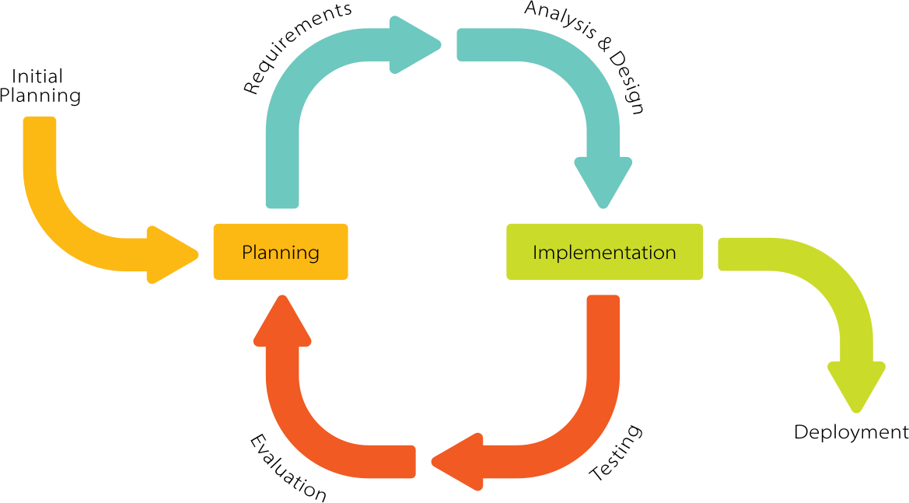

Figure 5.1: Iterative Development Model

* **A Design phase :** in which a software solution to meet the requirements is designed. This may be a new design, or an extension of an earlier design.
* **An Implementation and Test phase :** when the software is coded, integrated and tested.
* **A Review phase :** in which the software is evaluated, the current requirements are reviewed, and changes and additions to requirements proposed.

### Reconciled Estimates

#### Cost Estimates

The initial cost estimate of the project before beginning the implementation process is INR 3000 for in-house resources. This cost may vary. This estimate is subject to change according to the change according to the particular item. .

#### Time Estimates

The initial time estimate for the complete implementation of the primary objectives is 55- 60 days depending on the schedule of the developers. The secondary objectives require an additional efforts. Also, depending on the stage of development, the testing and debugging would require an additional of 15 days.

### Project Resources

#### People:

1. Project Members (Sakshi Dherange, Shital Mehetre, Vrushali Datir, Vrushali Patil)
2. Guide (Mrs. Deepali. M. Gohil)
3. Co-Guide (Mrs. Farina Sayyed)

#### Hardware

1. CPU Speed (2GHz)
2. RAM 8GB

#### Software

1. Operating System: Ubuntu 16.04 and above/Windows 8 and above.
2. IDE :Pycharm, Spyder.
3. Frontend: Tkinter
4. Backend: Python

## Risk Management w.r.t. NP Hard analysis

This section discusses Project risks and the approach to managing them.

### Risk Identification

For risks identification, review of scope document, requirements specifications and sched-ule is done. Answers to questionnaire revealed some risks.

#### Have top software and customer managers formally committed to support the project?

Crop Recommendation and leaf disease prediction using CNN which can only benefit the stakeholders. In today’s times, top software and customer managers have not formally committed to support the project but in near future they will.

#### Are end-users enthusiastically committed to the project and the system/product to be built?

Yes, Users will get complete benefit from the system and hence they are interested in it.

#### Are requirements fully understood by the team and its customers?

Yes, SRS has underlined all the requirements very clearly.

1. **Have customers been involved fully in the definition of requirements?** Yes, the customers will get complete benefit from the system and hence they are interested in it.

#### Do end-users have realistic expectations?

Yes.

#### Does the software engineering team have the right mix of skills?

Yes. The team was divided into two groups - Web and Backend teams according to the skills.

#### Are project requirements stable ?

Yes**.**

#### Is the number of people on the project team adequate to do the job?

Yes.

#### Do all customer/user constituencies agree on the importance of the project and on the requirements for the system/product to be built?

Yes. The project mainly focuses on data storage and cost efficient storage solutions which is the core important part of the current digital world.

### Risk Analysis

* Attacker goals

We need to consider what an attacker’s goals might be. The standard goals of any attacker in any security-relevant context are typically attacks against integrity, confidentiality, and availability.

* Privacy

The privacy of the users matter the most. And this is supposed to be anonymous.

### Overview of Risk Mitigation, Monitoring, Management

* To reduce the risks following actions can be taken:
  + Continuous data monitoring for real-time updates.
  + User training and technical support for the CNN model.
  + Predictive analytics to preemptively address potential issues.
  + Scalability options for handling increased data and user load

## Project Schedule

### Project task set

* UI modules
* Database designing
* Model building
* Integration after new model built
* Deployment

### Task network

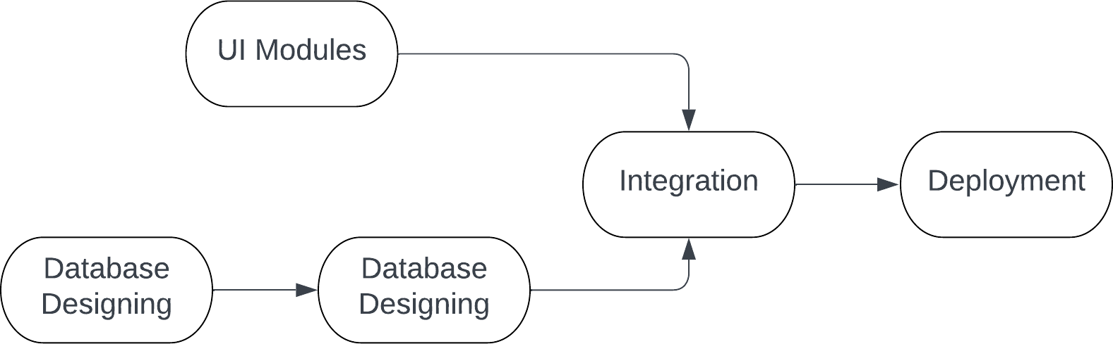

Figure 5.2: Fig. Task Network

### Timeline Chart

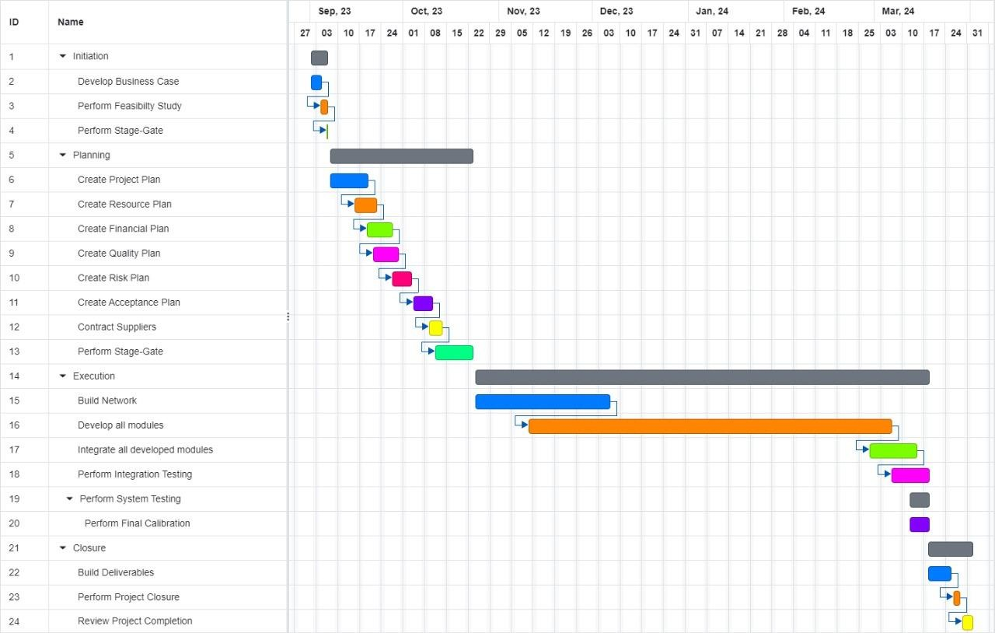

Figure 5.3: Fig. Time Line GANTT chart

## Team Organization

Our strategy is to divide the tasks amongst four of us. We decided a deadline for each task. In the end we combine the results of individuals into one single outcome.This is an approach of a Stage-Gate SDLC

### Team structure

|  |  |  |
| --- | --- | --- |
| Sr. No. | Name | Role |
| 1 | Sakshi Dherange, Shital Mehetre | Frontend , Data Collection |
| 2 | Vrushali Datir, Vrushali Patil | Documentation, Backend |
| 3 | Shital Mehetre, Vrushali Patil | Model building and training, Data Preprocessing, Backend |

Table 5.1: Team Structure for the Project

### Management reporting and communication

Dedicated Team of four developers working together and taking ownership of different actions to be performed with project progress is the attitude followed by following ways:

* Daily Scrums
* Inter team communications via virtual platforms
* Github Collaboration
* Guidance from Mentors on monthly basis

# Software requirement specification

## Introduction

"Crop Recommendation and Plant Leaf Disease Prediction" is a cutting-edge project at the intersection of agriculture and technology. It seeks to address the pressing challenges faced by farmers by providing them with data-driven solutions. This project is divided into two crucial components. The first component focuses on crop recommendation, utilizing historical data, soil analysis, and weather information to advise farmers on the best crop choices for their specific region. The second component involves plant leaf disease prediction, employing image recognition and predictive modeling to detect and forecast disease outbreaks in their early stages.

### Purpose and Scope of Document

The primary purpose of this document is to provide a comprehensive overview of the "Crop Recommendation and Leaf Disease Prediction using CNN" project. It aims to elucidate the project's objectives, methodologies, and outcomes in a structured manner. Within the scope of this document, readers will gain insights into the rationale behind developing a system for crop recommendation and leaf disease prediction using Convolutional Neural Networks (CNNs) in agriculture. Furthermore, this document outlines the project's key components, including dataset collection, data preprocessing, model architectures, training processes, and evaluation metrics. Additionally, it discusses the anticipated challenges, future work, and potential implications of the project. Readers can expect a detailed understanding of how CNNs can be applied to agricultural tasks, ultimately contributing to more informed and data-driven decisions in the agricultural sector .

### Overview of responsibilities of Developer

* System Design: Collaborate in designing the architecture and functionality of crop recommendation and plant leaf disease prediction using CNN, ensuring it aligns with the defined requirements.
* Coding: Write clean, efficient, and maintainable code in languages like Python, and others, implementing the features and functions.
* Testing: Thoroughly test the app for functionality, performance, and security, identifying and addressing issues and bugs.
* Security: Implement security measures, including data encryption and access controls, to protect user data and privacy.
* Machine Learning: Develop and integrate AI and ML models for price prediction, portfolio optimization, and real-time market analysis.
* User Experience (UX): Focus on delivering a user-friendly interface and responsive design across different web platforms.
* Scalability: Ensure the application can scale with increased user demand, optimizing performance and resource management.
* Collaboration: Collaborate with other team members, including designers and project managers, to achieve project goals and meet user expectations.

## Usage Scenario

#### Scenario 1: A successful login with valid credentials:

* 1. User needs to enter his login credentials.
  2. User enters his username.
  3. User enters his password.
  4. User logins successfully into the system.

#### Scenario 2: An unsuccessful login with wrong credentials:

* 1. User needs to enter his login credentials.
  2. User enters his username.
  3. User enters his password.
  4. But User couldn’t login successfully into the system.
  5. User presses forget password link.
  6. User gets password reset link on his registered email id.
  7. User resets his password and successfully logins into the system.

#### Scenario 3: Crop Suitability Assessment:

* 1. Capturing Leaf Images: When Sarah notices unusual spots or discolorations on her plant leaves, she takes clear photos of the affected leaves using her smartphone.
  2. Uploading Leaf Images: She uploads the leaf images to the app, specifying the type of plant the affected leaf belongs to (e.g., rose, tomato, or marigold).
  3. Disease Diagnosis: The app processes the images and provides a diagnosis of the likely disease affecting the plant. It might suggest possibilities like powdery mildew, aphid damage, or fungal infections.
  4. Treatment Recommendations: Based on the diagnosis, the app offers treatment recommendations. These suggestions may include organic remedies, chemical treatments, or pruning advice.
  5. Determine the suitability of various crops for planting based on the analyzed data. This assessment considers factors like soil type, temperature, precipitation, and the length of the growing season.

### User profiles

**Actor 1: Farmers**

* **Role:** Primary users of the system.

#### Requirements:

* + Access to a user-friendly interface for receiving crop recommendations and disease predictions based on local conditions.
  + Input capabilities to provide information about their farming practices, location, and environmental conditions.
  + Understandable recommendations and alerts for crop selection and disease management.
  + Access to historical data and reports for decision-making and planning.

#### Actor 2: Agricultural Experts and Consultants

* **Role:** Advisers and consultants in the agricultural sector.

#### Requirements:

* + Access to an advanced version of the system to assist multiple farmers.
  + The ability to analyze aggregated data and provide expert recommendations.
  + Tools for monitoring and offering guidance on crop health and disease management.
  + Data visualization and reporting for making informed decisions.

**Actor 3: System Administrators:**

* **Role**: System administrators are responsible for maintaining the project's infrastructure and ensuring its proper functioning.

#### Requirements:

* + Proficiency in managing servers, databases, and the application's backend.
  + Monitoring the system for errors, performance issues, and security concerns.
  + Keeping the application up-to-date and secure.

### Use-cases

|  |  |  |  |
| --- | --- | --- | --- |
| **Sr. No** | **Use case** | **Description** | **Actors** |
| 1 | **User Registration** | Allows users to create accounts for the system. | Farmers, Agricultural Experts |
| 2 | **User Login** | Enables registered users to log in to the system. | Farmers, Agricultural Experts |
| 3 | **Farm Profile Creation** | Users can input farm details such as location, soil type, and climate conditions. | Farmers, Agricultural Experts |
| 4 | **Crop Recommendation** | Based on farm profile, the system  recommends suitable crops for planting. | Farmers, Agricultural Experts |
| 5 | **Image Upload** | Users can upload images of crop leaves for disease prediction. | Farmers, Agricultural Experts |
| 6 | **Disease Prediction** | The system analyzes uploaded images and predicts if the crop has  any diseases. | Farmers, Agricultural Experts |
| 7 | **View Recommendations** | Users can access and review crop  recommendations provided by the system. | Farmers, Agricultural Experts |
| 8 | **User Registration** | Allows users to create accounts for the system. | Farmers, Agricultural Experts |
| 9 | **User Login** | Enables registered users to log in to the system. | Farmers, Agricultural Experts |
| 10 | **Farm Profile Creation** | Users can input farm details such  as location, soil type, and climate conditions. | Farmers, Agricultural Experts |
| 11 | **Crop Recommendation** | Based on farm profile, the system  recommends suitable crops for planting. | Farmers, Agricultural Experts |
| 12 | **Image Upload** | Users can upload images of crop leaves for disease prediction. | Farmers, Agricultural Experts |
| 13 | **View Disease Predictions** | Users can check disease  predictions for their crops and receive treatment suggestions. | Farmers, Agricultural Experts |
| 14 | **System Maintenance** | System administrators ensure the  smooth functioning of the application and server. | System Administrators |

### Use Case View

Use Case Diagram. Example is given below

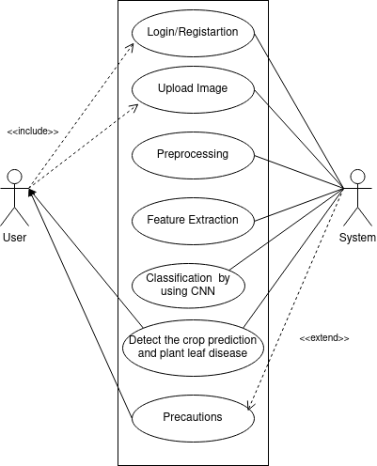

Figure 6.1: Use Case Diagram

## Functional Model and Description

A description of each major software function, along with data flow (structured analysis) or class hierarchy (Analysis Class diagram with class description for object oriented system) is presented.

### Data Flow Diagram

#### Level 0 Data Flow Diagram



Figure 6.2: DFD Level 0

#### Level 1 Data Flow Diagram

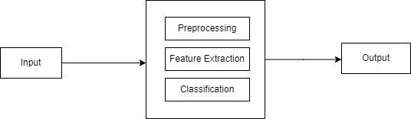

Figure 6.3: DFD Level 1

#### Level 2 Data Flow Diagram

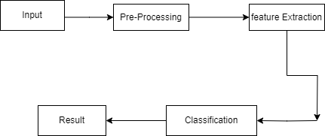

Figure 6.4 : DFD Level 2

### Activity Diagram:

### 

Figure 6.5: Activity Diagram

### Non- Functional Requirements:

* **Usability:** An easy-to-use interface is a necessary for software. Users should be able to navigate between pages more easily, saving them time and confusion.
* **Security:** Sensitive data should have enhanced security; data tampering should not be permitted. Ensuring that data can only be accessed by authorized individuals and that all actions are recorded would allow for comprehensive role-based permission.
* **Deployment:** Using a web browser or an app, each user should establish an Internet connection to the application.
* **Backup:** To ensure that no data is lost, there should be a sufficient backup option for all of the data.
* **Platform/Browser Independence:** The system ought to function on all current browsers, including Firefox and Chrome, as well as any of the modern browsers like Firefox/ Chrome, and any of the common OS like Linux, Windows.

### State Diagram:

Figure 6.6 The state transition diagram for crop recommendation and leaf disease prediction using CNN is displayed in the example below. The states are shown as ovals, and when specific things happen, the system's state changes. Arrows are used to show how one state changes into another. Important phases and activities that take place when starting a new project are depicted in the figure.

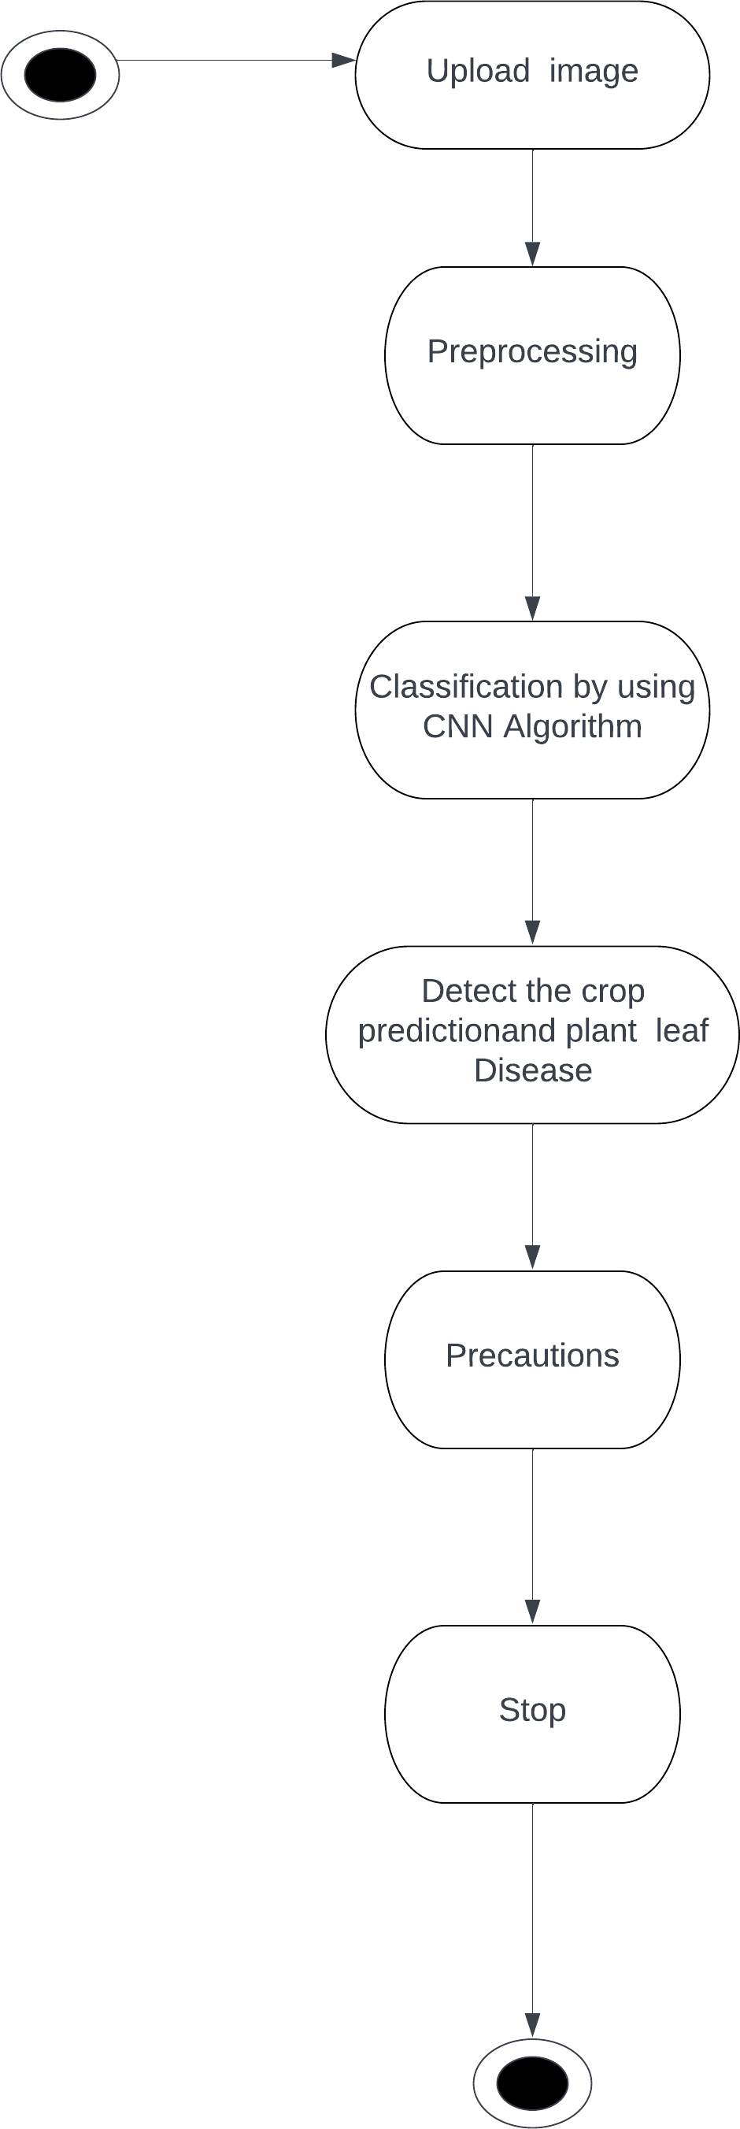

Figure 6.6: State Transition Diagram

### Software Interface Description

1. User Registration: Allows account creation.
2. User Login: Enables user access.
3. Farm Profile Creation: Input farm details.
4. Crop Recommendation: Recommends suitable crops.
5. Image Upload: Allows uploading of crop images.
6. Disease Prediction: Analyze and predicts crop diseases.
7. View Recommendations: Access crop recommendations.
8. View Disease Predictions: Check disease predictions and treatment suggestions.
9. Data Collection: Collect and upload crop images with annotations.
10. System Maintenance: Ensures system functionality.
11. Research and Model Development: Experiment with CNN architectures.
12. Data Sharing: Allows access to aggregated data and insights.

# Design Document

## Introduction

"Crop Recommendation and Plant Leaf Disease Prediction" is a cutting-edge project at the intersection of agriculture and technology. It seeks to address the pressing challenges faced by farmers by providing them with data-driven solutions. This project is divided into two crucial components. The first component focuses on crop recommendation, utilizing historical data, soil analysis, and weather information to advise farmers on the best crop choices for their specific region. The second component involves plant leaf disease prediction, employing image recognition and predictive modeling to detect and forecast disease outbreaks in their early stages.

## Data design

### Internal software data structure

The internal software data structure for the "Crop Recommendation and Leaf Disease Prediction using CNN" project is designed to efficiently handle and organize data. It includes a database schema to store farm profiles, crop recommendations, and disease prediction results. Additionally, image repositories are set up to manage the collection of crop images and their annotations. These structures facilitate the seamless retrieval and storage of information critical to the project's decision-making processes and user interactions.

### Database description

In the "Crop Recommendation and Leaf Disease Prediction using CNN" project, we employ the SQLite database system (SQLite3) as the underlying database for data management. SQLite is a lightweight, embedded database that is particularly suitable for applications where a full-fledged database server may be unnecessary. It stores data in a local file, making it highly efficient for our project's purposes. The database is structured to store essential information, such as user account data, farm profiles, crop recommendations, and disease predictions. It offers excellent support for data retrieval and management, and its simplicity ensures smooth integration into our application, whether for user registration, data storage, or information retrieval needs. By using SQLite3, we can maintain data consistency and reliability, crucial for the success of the project's decision-making and user-interaction functionalities.

## Architectural Design

This diagram depicts the process of uploading an image to a train database with images. The user, who is using a computer, uploads the image. The image is then preprocessed by converting it to grayscale. Next, the image is uploaded to the train database with images. After that, the image is processed by extracting features from it. This includes detecting parameters from the fetal image uploaded for testing. The CNN algorithm then works by matching the extracted features with the features of trained images in the dataset. The final step is to crop the prediction and plant disease, and display the output to the user.

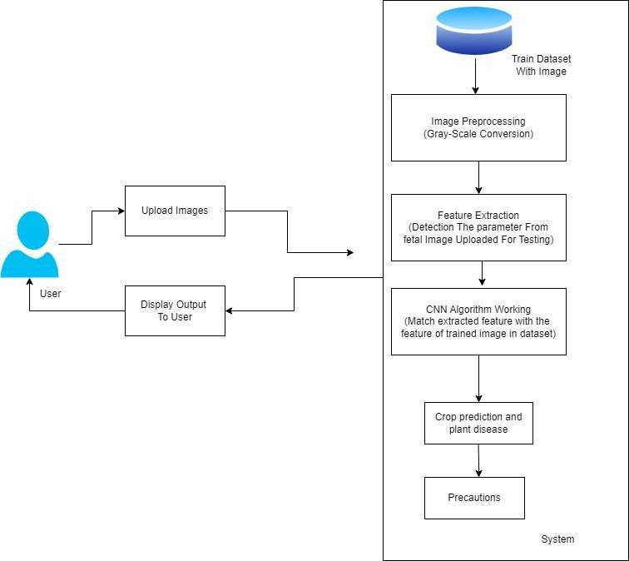

Figure 7.1: System Architecture

## Component Design

### Sequence Diagram

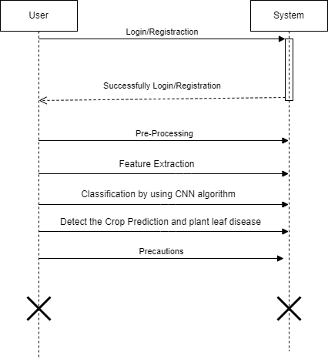

Figure 7.2: Sequence Diagram

# Project Implementation

## Introduction

"Crop Recommendation and Plant Leaf Disease Prediction" is a cutting-edge project at the intersection of agriculture and technology. It seeks to address the pressing challenges faced by farmers by providing them with data-driven solutions. This project is divided into two crucial components. The first component focuses on crop recommendation, utilizing historical data, soil analysis, and weather information to advise farmers on the best crop choices for their specific region. The second component involves plant leaf disease prediction, employing image recognition and predictive modeling to detect and forecast disease outbreaks in their early stages.

## Tools and Technologies Used

1. Python
2. DBSQLITE3
3. Spyder
4. Anaconda
5. Python libraries
6. VS studio Code

## System Modules

### User Management Module

Manages user interactions in all its facets, including safe login and registration procedures. By controlling user roles and permissions, it makes sure that various users—such as farmers, agronomists, and administrators—have the right amount of access.

### Crop Recommendation Module

Makes customized crop suggestions by applying machine learning algorithms to analyze soil and climate data. To customize recommendations, it takes into account user inputs like favored crops and regional conditions. The objective of this module is to maximize crop production and optimize resource utilization.

### Disease Detection Module

In this module, uses photos of plant leaves to identify and diagnose plant illnesses using Convolutional Neural Networks (CNNs). Prior to analysis, it preprocesses photos by normalizing and resizing them. Based on identified symptoms, the module offers precise disease diagnosis and treatment recommendations.

# Software Testing

Software testing is necessary to determine whether the product that is needed and the product that is constructed meet the expected requirements. Software testing is the process of ensuring that there are no defects in the program and determining whether the actual result matches the expected outcome. Finding mistakes, gaps, or needs that are missing in comparison to the real requirement is helpful. Software testing can be carried out automatically or manually.

## Type of Testing Used

* Functional Testing
* Non-Functional Testing or Performance Testing
* Maintenance (Regression and Maintenance)
  + **Integration Testing:** This testing is conducted to confirm the proper functioning of the fully integrated components of a food sales prediction application. It describes the scope and basis for integration testing, testing of internal and external system interface, testing of security capabilities, testing of accessibility features. System-level qualification tests address the integrated operation of hardware, software to assess the system’s response.
  + **Unit Testing:** Unit testing is used to test individual component of the application. Alpha testing: Alpha testing is conducted to identify all possible issues or defects before releasing final working.
  + **Alpha testing:** Alpha testing is conducted to identify all possible issues or defects before releasing final working system.
  + **Back-end Testing:** Whenever an input or data is entered on front-end application, it stores in the databases and the testing of such database is called as back-end testing.
  + **Black-box testing:** This testing analyses the functionality of the system without knowing much about the internal structure or design of the item that is being tested and compares the input value with the output value.
  + **Component testing:** The testing of multiple functionalities as a single code and its objective is to identify if any defect exits after connecting those multiple functionalities with each other.
  + **End-to-End Testing:** Testing of complete application environment in a situation that mimics real world use is performed.

**Functional Testing:** Functional testing is performed by focusing only on the output to check if it is as per the requirement or not.

* + **Graphical User Interface (GUI) Testing:** It includes the testing of size of the buttons and input field present on the screen, alignment of all text, tables and content in the table.
  + **Performance Testing:** To check whether the system meets the performance requirements.

## Test Cases

|  |  |  |  |  |
| --- | --- | --- | --- | --- |
| **Test Case ID** | **Input** | **Expected Output** | **Actual Output** | **Result** |
| TC-001 | User profile creation  data (location, soil type, climate) | Valid farm profile created successfully | Valid profile created successfully | Pass |
| TC-002 | Crop image upload with disease | Accurate disease prediction and treatment recommendation | Accurate prediction and recommendation | Pass |
| TC-003 | Crop image upload without disease | Accurate disease prediction (no disease  detected) | Accurate prediction (no disease detected) | Pass |
| TC-004 | User login with valid credentials | User successfully logged in | User successfully logged in | Pass |
| TC-005 | User login with invalid credentials | Authentication error message displayed | Authentication error message displayed | Pass |
| TC-006 | Access crop recommendations | Recommendations displayed based on farm profile | Recommendations displayed based on farm profile | Pass |
| TC-007 | Access disease predictions | Disease predictions displayed for uploaded images | Disease predictions displayed for uploaded images | Pass |
| TC-008 | Data collector uploads annotated crop images | Images and annotations successfully added to the dataset | Images and annotations successfully added to the dataset | Pass |
| TC-009 | System maintenance and monitoring | No critical errors or issues reported | No critical errors or issues reported | Pass |
| TC-010 | Researcher experiments with CNN models | Models produce accurate predictions and maintain performance | Models produce accurate predictions and maintain performance | Pass |

Table 9.1: Testcases

\

# Results

## Screenshots

# 

# 

# Fig 11.1 Application Landing Page

# 

# 

# Fig 11.2 Registration screen

# 

# 

# 

# Fig 11.3 Registration screen

# 10.2 Outputs

# 

# 

# Fig 11.4 Crop Recommendation

# 

# Fig 11.5 Plant Leaf Disease Predication

# Deployment and Maintenances

## Operational Requirements to run the System

1. Python 3.11
2. Anaconda Navigator
3. Spyder 5.0
4. Microsoft Visual Studio Code

# 12. Conclusion an future scope

The "Crop Recommendation and Leaf Disease Prediction using CNN" project embodies the promise of data-driven innovation in agriculture. Through the strategic use of Convolutional Neural Networks (CNNs), the project empowers farmers with personalized crop recommendations and early disease detection, contributing to improved resource management and crop health. This initiative not only addresses immediate agricultural challenges but also paves the way for sustainable and efficient practices. In a world facing evolving environmental conditions and a growing need for food security, this project serves as a beacon of hope, highlighting the pivotal role of technology in transforming agriculture. It underscores the potential for data-driven decision-making to enhance crop yields, protect food supplies, and support the livelihoods of farmers, ultimately ensuring a more secure and sustainable future.

#### Future Scope:

1. Enhanced Disease Detection Models: Develop more advanced disease detection models, potentially using state-of-the-art deep learning architectures to improve accuracy.
2. Multi-lingual Support: Implement multi-lingual support for a broader range of users, especially in regions with diverse languages.
3. Mobile Application: Create a mobile application for on-the-go access to crop recommendations and disease predictions, making it more convenient for farmers.
4. IoT Integration: Integrate Internet of Things (IoT) devices for real-time data collection, such as soil moisture and weather conditions, to provide more precise recommendations.
5. Geographic Expansion: Expand the project's coverage to more regions and crops, catering to a wider agricultural audience.

# Appendix B (Idea Matrix)

|  |  |  |  |  |
| --- | --- | --- | --- | --- |
| **Modules** | **Technology to be used** | **How it will be used** | **Time Allotted** | **Responsible Person** |
| Login/ Registration | Python | Primary programming language for developing the project's algorithms and backend. | 1-2 weeks | Sakshi, Shital, Vrushali D., Vrushali P. |
| Anaconda | Used for Python environment management, simplifying library and package installations. | 2 weeks |
| DBSQLITE3 | The chosen database system for efficient data storage and retrieval in the project. | 2 weeks |
| Spyder | Integrated development environment (IDE) for Python, facilitating code development and debugging. | 2-3 weeks |

**REFERENCES**

1. Wasswa Shafik, Ali Tufail, Abdallah Namoun, Liyanage Chandratilak De Silva, And Rosyzie Anna Awg Haji Mohd Apong, “A Systematic Literature Review On Plant Disease Detection: Motivations, Classification Techniques, Datasets, Challenges, And Future Trends’’,2023.
2. Hussain Alshahrani, Hend Khalid Alkahtani , Khalid Mahmood, Mofadal Alymani, Gouse Pasha Mohammed, Amgad Atta Abdelmageed, Sitelbanat Abdelbagi, And Suhanda Drar, “Chaotic Jaya Optimization Algorithm With Computer Vision-Based Soil Type Classification For Smart Farming”,2023.
3. M Chandraprabha, Rajesh Kumar Dhanaraj, “Machine Learning Based Pedantic Analysis Of Predictive Algorithms In Crop Yield Management”, 2020.
4. S. P. Raja, Barbara Sawicka, Zoran Stamenkovic, And G. Mariammal, “Crop Prediction Based On Characteristics Of The Agricultural Environment Using Various Feature Selection Techniques And Classifiers”, 2022.
5. Jianyu Su, Meihua Wang, Zhenxin Wu, And Qingliang Chen, “Fast Plant Leaf Recognition Using Improved Multiscale Triangle Representation And Knn For Optimization”, 2020.
6. Rahal Bency Paul, Roshen Reji George, Sachin Sajikumar, Sreelakshmi R Prince Abraham, “Image Based Disease Detection and Solution Prediction in Plant Leaves”, 2020.
7. Prof. A. V. Deorankar, Ashwini A. Rohankar, “An Analytical Approach for Soil and Land Classification System using Image Processing”,2020.
8. Ms. Supriya S. Shinde, Mrs. Mayura Kulkarni, “Review paper on Prediction of Crop Disease Using IoT and Machine Learning”,2021

**Paper Published Status**

1. **Paper Title**: Crop Recommendation and Plant Leaf Disease Prediction using CNN
2. **Name of the Conference/Journal where paper submitted**: IJEAST (International Journal of Engineering Applied Science and Technology) (ISSN: 2455-2143)
3. **Paper accepted/rejected:** Submitted and Accepted

# Plagiarism Report

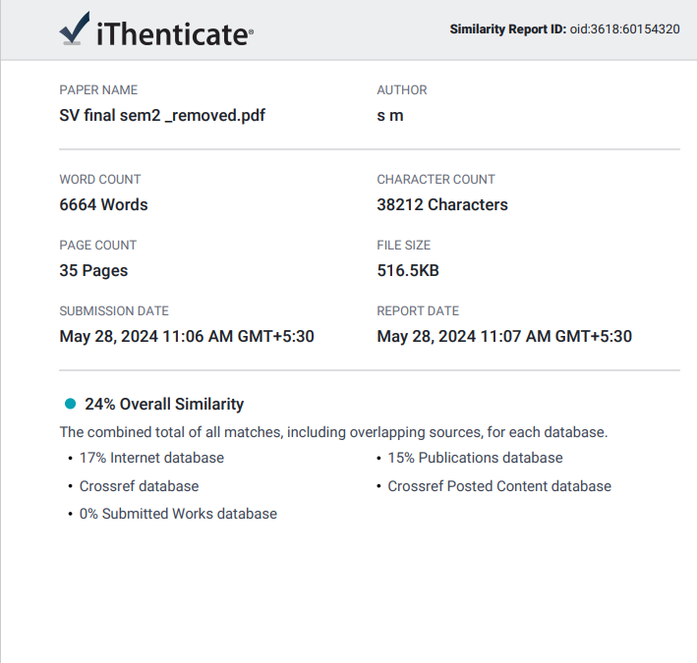

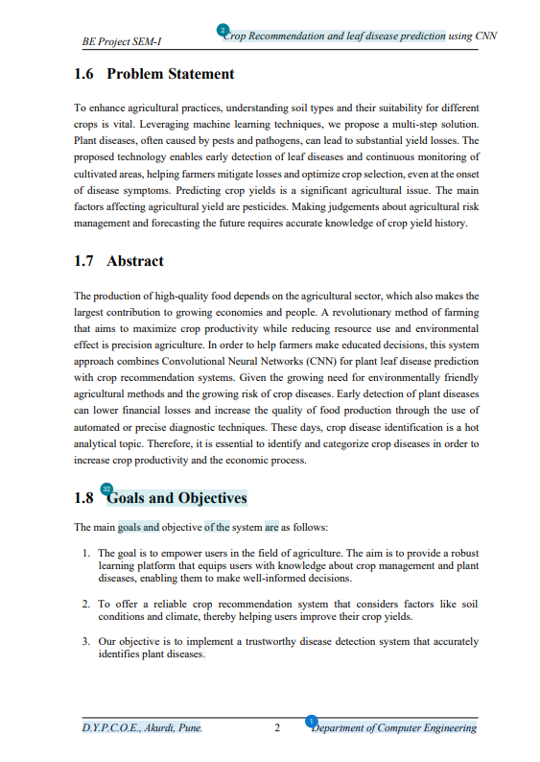

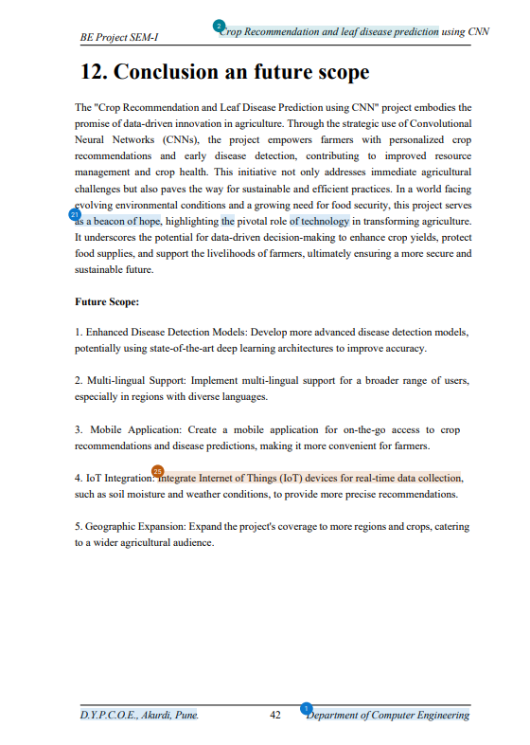

# 

# Information of Project Group Members

1. Sakshi Dherange
   * Date of birth: 15 March, 2003
   * Gender: Female
   * Address: Pune
   * Email: [sakshidherange153](mailto:ayushi.p.n@gmail.com)[@gmail.com](mailto:yushi.p.n@gmail.com)
   * Contact Number: +91 7385736616
2. Shital Mehetre
   * Date of birth: 12 December, 2002
   * Gender: Female
   * Address: Pune
   * Email: mehetreshital12[@gmail.com](mailto:vyanirathod007@gmail.com)
   * Contact Number: +91 7843030411
3. Vrushali Datir
   * Date of birth: 24 June, 2003
   * Gender: Female
   * Address: Pune
   * Email: vrushalidatir06[@gmail.com](mailto:apnil.londhe24@gmail.com)
   * Contact Number: +91 9130576122
4. Vrushali Patil
   * Date of birth: 06 May, 2001
   * Gender: Female
   * Address: Pune
   * Email: vrushalipatil0605[@gmail.com](mailto:hdeshmukh40@gmail.com)
   * Contact Number: +91 8530388574